How can games technology be used to create playful experiences in public spaces?
Must | Location from device determines what water body the player is near  Location from device determines the type of location (city, woodland etc)  A fishing game loop where players catch fish based the water body type
Should | A location specific environment which the player can explore  Different fish icons for
Could | A map that pinpoints where the player has caught fish
Wish | Online leaderboard to compete against friends

Abstract
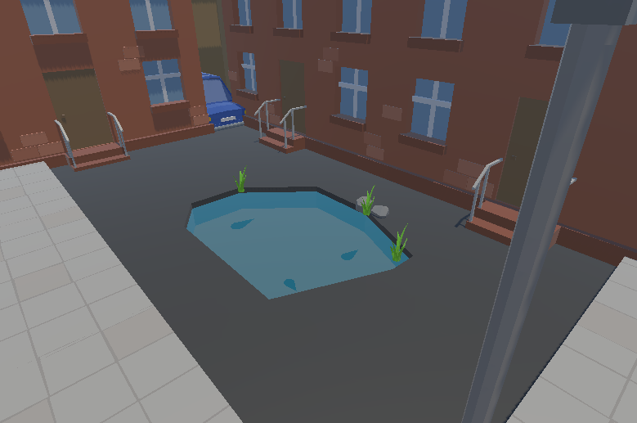
Bow Dougans
Department of Computer Science and Creative Technologies
University of the West of England
Coldharbour Lane
Bristol, UK
bow2.dougans@live.uwe.ac.uk

This document outlines how games technology can create playful experiences in public spaces, showcased through a location-based fishing prototype.
Research for this prototype is based primarily around location data extracted from OpenStreetMap via QGIS, which allowed for offline development and gameplay. Research also looking into existing fishing mechanics in popular games, and how the prototype can create a system of catching fish and maintaining personal records.
The prototype features interactive fishing mechanics and how the location can be used to modify this fishing system. Further features showcase placed map markers showing captured fish, with opportunity to create an online experience for the player.

Author Keywords
Location; map; fishing

Introduction
This report outlines the research and implementation of methods used to showcase how games can be used to create playful experiences in public spaces.
Throughout development, the MoSCoW method was used, as shown in figure 2, to prioritise the key features of the project. While the main aspect of the game utilizes location-based fish catching, there are also ways of building on this system to create a more interactable environment for the player.
The main research and implementations of this project are based upon information that can be gathered from the location of the player, while also looking at fishing systems in other games.

Background Research
Extracting data from a map was a key part of – for this prototype. This could be achieved using two methods, using map API’s such as Google Maps (Google, 2025) or MapBox (Mapbox 20whatever), or by extracting data from a snapshot of a map from websites such as OpenStreetMap () or Natural Earth ().
Using an API like this allows for dynamic access to location data, such as route navigation, points of interest and location services. API’s are ideal for real time updates, however a drawback of this is that these updates are not available offline, locking the user to online play only.
Using software to extract the data allows for the data to be saved and stored inside the app, making it available to play offline. Using extracted data however means that developers will need to manually update areas if there are changes to the environment, such as man-made water bodies being created.
For this prototype, using a snapshot from a map was used as this method does not require online access and permissions from an API, allowing for offline development and testing. To extract this data, a program called QGIS was used, which is an open source, modular software which has a wide range of tools made for geographical purposes. Another tool that can be used for this kind of data analysis is ArcGIS, which provides commercially available tools.
For fishing mechanics, research was based on already existing games that have fishing systems.
In Animal Crossing (Nintendo, 2002), fish shadows lay in the water with varying sizes, indicating to the player that there are catchable fish in that water body. The player can then cast their rod nearby the fish, and if the bobber is in the line of sight and radius of the fish, it will swim towards it and bite down, allowing the player to catch it.
Stardew Valley (ConcernedApe, 2016) allows the player to view their caught fish inside their ‘fishing log’. This displays an image of the fish, the number of times the player caught this fish, and the largest catch.
WebFishing (Lamedeveloper, 2024) has similar mechanisms to both Animal Crossing and Stardew Valley, however has an online aspect that allows players to talk, trade and send gifts to each other.
Elements of all these games can be used to create a system in a mobile game, by utilizing aspects of the fishing systems and holding personal records. These can be expanded to include online play, such as sharing records. However due to the scope of the project this has been placed into the ‘wish’ section of the MoSCoW layout.
To create the environments, research was done into existing low-poly assets to create a cartoon style environment that reflected the style of the game, with hand drawn fish and UI assets. Websites with free asset packs such as itch.io were used to find these models.

Outcomes
A limitation from using OpenStreetMap is when downloading a .osm file, there is a limit of 50000 nodes. This is fine for places like woodland or countryside, however in a city such as Bristol where this prototype was being developed, nodes include things such as buildings and roads, therefore the prototype could only use a snapshot of a smaller area of the city, despite only using the data of the water.
Another issue that arose during development was water bodies being missing from the data or having a null result when filtering the tags inside QGIS. As OpenStreetMap is open source and contributed to by the public, it is possible that the data collected for that water sample was not relevant to the person collecting it, so they rejected that data. Man made bodies of water also resulted in a null or missing, as when the data was obtained it is possible they did not exist. To overcome this, any values that returned null would return ‘other’ inside the QGIS field calculator. (figure ??) If the player is within range of a ‘other’ water body, they will instead catch fantasy fish.
From the .osm file, the latitude and longitude of the water bodies were extracted to compare against the coordinates of the device. The type of water body, as well as the type of area, were also extracted as seen in figure --. This information was exported from QGIS into a .csv file, which was placed into the prototype.
Different environments were created that correspond to where the player is. The player would be placed into an environment that reflects where they are, such as a pond in a city or a river in a city. In these environments, players can walk around next to water bodies with fish are placed for the player to catch.
To catch the fish the player can tap a location on the water to where they want to cast to, if the bobber is in range of the fish the fish can swim towards this bobber, allowing the player to reel it in. The prototype features a simple throwing animation where the bobber moves along a curve from the player into the water, to represent casting a line. Once caught, the name and an image of the fish that you caught is displayed on screen. This data is used to create a pinpoint on the player’s map.
In the corner of the screen there is a map button, which the player can press to show a map of where they are. This is currently a static image, using the same map that was imported into QGIS for data extraction. The map script takes the coordinates of the device and converts them into a screen position by comparing them to the map’s top left and bottom right coordinates. The code turns these values into pixels to place the marker on the correct area of the map image. The placed down marker can be clicked on, showing the name, image and date of when the fish was caught.

Evaluation
Overall, the prototype successfully showcases the integration of games technology in a public space to create a playful experience.
This project could be expanded further by extending the area of which the game is functional, linking back to the research this could be done using an API, which provides a snapshot of the players location dynamically, rather than using data stored inside the game itself.
Using an API would also provide better support for the map pinpoint aspect, as the prototype uses a static image of where development took place. This method would also allow for players to see other pinpoints from other users, making the game have a community aspect.
While the fishing mechanics work well, multiple features of the system could be improved further, such as having the options to sell your fish to buy better rods, which in turn allows the player catch better fish.

References

